Conkit – Console Kit
This is a header to provide abstractions for operations involving the console across different platforms. It is programmed with console-based applications in-mind, while leaving the user with the freedom to structure their program how they wish.

Basis
The basis of an application using conkit.h is simply to include the header file, and initialise it before any operations involving it take place, and end it thereinafter. Between these two points, the programmer may choose to implement whichever parts of it that they want, in any way that they wish. Functions and macros for handling console input and output are provided, as well as a display-buffering system that the programmer may or may not wish to use. This is all that the header-file was built to do, and no additional functionality is provided. In-future, extra functionality may be added to Conkit if it pertains to this basis of operation, and functions may be refactored and optimised, but described behaviour will not change and backwards-compatibility will be strived-for.

Basic Application Structure
Currently, only Windows and Unix-like platforms are supported. This may change in the future, but but for now if it does not fall into either of these categories, an error will be raised during compilation if the platform in-question could not be determined. If your system is compliant with one of these, defining unix, __unix, __unix__, __APPLE__, or __MACH__ for a Unix-like system, or _WIN32 for a Windows system should fix the issue.

The programmer must invoke a call to ck_init() before using any other part of the library anywhere. Failing to do so will produce undefined behaviour. In addition, ck_end() is strongly advised to be called upon when functionality from Conkit is no longer required for the entirety of the program’s remaining runtime.

Here is an example:
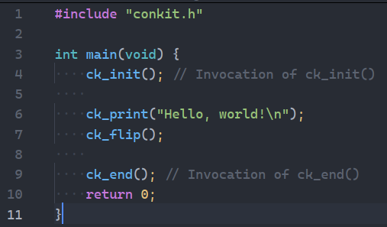

List of Definitions within conkit.h
Items wholly relevant to the user will have their name in blue:
Name | Classification | Datatype | Platform | Description
struct ck_console_size | struct (datatype) | struct {  size_t width,  height;  _Bool has_changed;  }; | Both | Return type of ck_current_console_size(): width = current console width (columns), height = current console height (lines), has_changed = does the width or height differ from last time ck_current_console_size() was invoked?
CK_ALLOC_BUFFER | global | void * | Both | Buffer for memory reallocation, to maintain the CK_SCREEN_BUFFER pointer in case reallocation fails, in order to free it safely
CK_SCREEN_BUFFER_SIZE | global | size_t | Both | Size of CK_SCREEN_BUFFER, in characters
CK_SCREEN_BUFFER_END | global | size_t | Both | Index of last character printed to CK_SCREEN_BUFFER.
CK_SCREEN_BUFFER | global | char * | Both | Buffer to which all printing intended for output should be done, so that it can all be outputted in one go once the drawing process is complete.
CK_SEQUENCE_BUFFER | global | char * | Both | Buffer to which strings containing ANSI escape-sequences are written in the non-literal-argument implementations of the sequence-generation functions. Note that because this buffer is shared between all of these functions, successive writes by each of them will overwrite the contents of the buffer. This means that calling these functions for a return value as an argument to a surrounding function-call will result in only the last call’s generated sequence being used as the string for each of the others. literal-argument implementations do not suffer from this issue as they do not use a buffer. To avoid this issue, maybe something like strdup() on the return value of the function would be advisable, should you wish to use them in-sequence.
CK_ALLOC_SIZE | global constant | Macro: #define CK_ALLOC_SIZE | Both | Indicates an amount of chars that buffer sizes will start at and be reallocated by should they need it. Consequently, the larger this size is, the faster your program will be with initial writes to buffers as less reallocation will be required, but the more memory will be used.
CK_STD_OUTPUT_HANDLE | global | HANDLE | Windows | Handle for Standard Output that is used to enable ANSI escape-sequences and acquire the size of the console.
CK_CONSOLE_MODE | global | DWORD | Windows | Console mode DWORD for enabling ANSI escape sequences and eventually resetting the modes back to the way they were.
sleep() | function | Macro: #define sleep(ms) | Both | Function to sleep a number of milliseconds, wrapped as sleep(), backending to either usleep() or Sleep() depending on the platform.
ck_init() | function | Function: void ck_init(void) | Both | Initialises Conkit, allocating memory for buffers and performing implementation-specific tasks and pre-computations.
ck_end() | function | Function: void ck_end(void) | Both | Frees memory and performs necessary reversions after Conkit is no longer needed.
ck_current_console_size() | function | Function: struct ck_console_size ck_current_console_size(void) | Both | Returns the current width and height of the console, measured in lines and columns of characters, and additionally whether these values have changed since the last call to this function was performed.
CK_CONSOLE_SETTS | global | struct termios | Unix-like | Non-buffered, non-echoed configuration-attribute for usage by getch() and kbhit() implementations.
CK_CONSOLE_ORIG_SETTS | global | struct termios | Unix-like | Original configuration-attribute for the console used to restore the existing configuration once usage of the terminal in the  CK_CONSOLE_SETTS configuration is complete, within the runtime of the getch() and kbhit() functions.
ck_rgb() | function | Function: char *ck_rgb(unsigned char where, unsigned char r,  unsigned char g, unsigned char b) | Both | Non-literal-argument sequence-generation function for setting terminal to output in a certain (r, g, b) colour.
CK_CLEAR_CONSOLE | global constant | Macro: #define CK_CLEAR_CONSOLE | Both | Alias for escape sequence to clear the console window (equivalent to “\033[2J”)
CK_RESET_FORMATTING | global constant | Macro: #define CK_RESET_FORMATTING | Both | Alias for escape sequence to reset formatting to the way it was before any changes were applied (e.g. a printing of ck_bg_rgb(…)). It is equivalent to “\033[0m”
CK_HIDE_CURSOR | global constant | Macro: #define CK_HIDE_CURSOR | Both | Alias for escape sequence to make the cursor invisible in the console window (equivalent to “\033[?25l”)
CK_SHOW_CURSOR | global constant | Macro: #define CK_SHOW_CURSOR | Both | Alias for the escape sequence to make the cursor visible in the console window, if it is currently invisible (equivalent to “\033[?25h”)
ck_bg_rgb() | function | Macro: #define ck_bg_rgb(r, g, b) | Both | Non-literal-argument sequence-generation function for setting the terminal background colour to a certain (r, g, b) value.
ck_fg_rgb() | function | Macro: #define ck_bg_rgb(r, g, b) | Both | Non-literal-argument sequence-generation function for setting the terminal foreground colour to a certain (r, g, b) value.
ck_cursor_goto() | function | Function: char *ck_cursor_goto(size_t x, size_t y) | Both | Non-literal-argument sequence-generation function for moving the cursor in the console such that it may print at a specified set of co-ordinates (x, y). x is 0-… and goes from left to right, y is 0-… and goes from top to bottom.
ck_cursor_move() | function | Function: char *ck_cursor_move(char where, size_t amount) | Both | Non-literal-argument sequence-generation function for moving the cursor on the console in a specific direction relative to its current position, by a specified amount.
ck_cursor_up() | function | Macro: #define ck_cursor_up(amount) | Both | Non-literal-argument sequence-generation function for moving the cursor on the console upward by a specified amount.
ck_cursor_down() | function | Macro: #define ck_cursor_down(amount) | Both | Non-literal-argument sequence-generation function for moving the cursor on the console downward by a specified amount.
ck_cursor_left() | function | Macro: #define ck_cursor_left(amount) | Both | Non-literal-argument sequence-generation function for moving the cursor on the console leftward by a specified amount.
ck_cursor_right() | function | Macro: #define ck_cursor_right(amount) | Both | Non-literal-argument sequence-generation function for moving the cursor on the console rightward by a specified amount.
ck_bg_rgb_l() | function | Macro: #define ck_bg_rgb_l(r, g, b) | Both | Equivalent of ck_bg_rgb(), but preferable to that if the arguments will be literals, due to less overhead.
ck_fg_rgb_l() | function | Macro: #define ck_fg_rgb_l(r, g, b) | Both | Equivalent of ck_fg_rgb(), but preferable to that if the arguments will be literals, due to less overhead.
ck_cursor_goto_l() | function | Macro: #define ck_cursor_goto_l(r, g, b) | Both | Equivalent of ck_cursor_goto(), but preferable to that if the arguments will be literals, due to less overhead.
ck_cursor_up_l() | function | Macro: #define ck_cursor_up_l(amount) | Both | Equivalent of ck_cursor_up(), but preferable to that if the arguments will be literals, due to less overhead.
ck_cursor_down_l() | function | Macro: #define ck_cursor_down_l(amount) | Both | Equivalent of ck_cursor_down(), but preferable to that if the arguments will be literals, due to less overhead.
ck_cursor_left_l() | function | Macro: #define ck_cursor_left_l(amount) | Both | Equivalent of ck_cursor_left(), but preferable to that if the arguments will be literals, due to less overhead.
ck_cursor_right_l() | function | Macro: #define ck_cursor_right_l(amount) | Both | Equivalent of ck_cursor_right(), but preferable to that if the arguments will be literals, due to less overhead.
ck_print() | function | Function: void ck_print(char *buffer) | Both | Allows the writing of a string to the CK_SCREEN_BUFFER, so that it may be sent to stdout when ck_flip() is eventually called.
ck_flip() | function | Function: void ck_flip(void) | Both | Print the contents of the CK_SCREEN_BUFFER, starting at (0, 0) on the console, and subsequently clear it.
getch() | function | Function: char getch(void) | Both | Get 1 character of input without printing the character to the console when it is typed-out, or waiting for a newline to return.
kbhit() | function | Function: _Bool kbhit(void) | Both | Returns whether there is any input on stdin.

Getting Started
If you are writing an application that requires frequent redrawing of what is being printed to the screen, a main-loop structure may be advised. Here is an example of such:
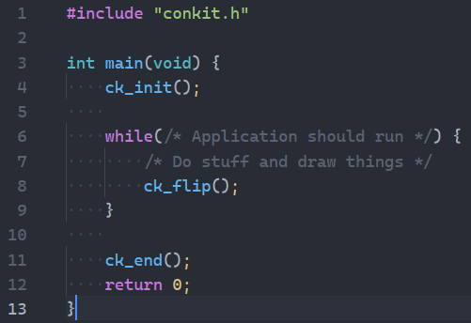

Conkit is initialised before the main-loop with ck_init(), the drawing is done in the mainloop before it is outputted with ck_flip(), and after the mainloop ends the cleanup is completed with ck_end().

Here’s a functional example:
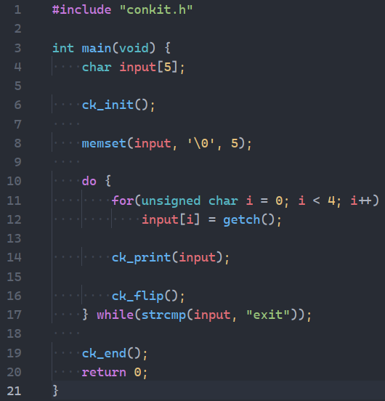

Here, the example uses a blocking function in the main-loop, so is not how your typical example might look, but illustrates the point just fine. For every loop, four characters of input are written to ‘input’. Then, input is written to the CK_SCREEN_BUFFER with ck_print(), and the contents of this is outputted to the console from point (0, 0) with ck_flip(). The main loop terminates if what was written to ‘input’ was the string “exit”.

What if you wanted to always print this half-way down the window, though, and print the characters as soon as they’d been inputted? To do this we’d need to cater to window-resizing, and go for a more traditional mainloop program-structure:
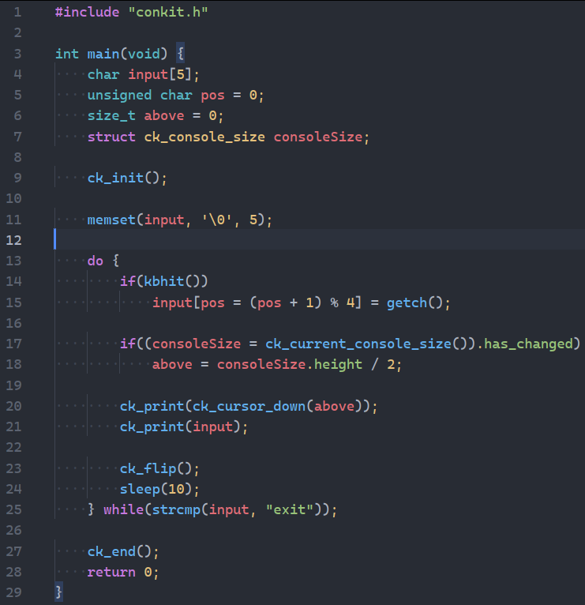

Here we loop constantly, until input contains the string “exit”. Every time we loop, we detect if the keyboard was pressed with kbhit(), and if it was, insert the character into input in the correct position. Then, we check if the window has been resized, with the has_changed attribute of the ck_current_console_size() return value. If it has, we alter the amount to move downwards from (0, 0) when updating the output accordingly. Then, we write to the buffer the sequence for moving the cursor down by the set amount, and following this, the contents of input. Then, we flip the display and wait 10ms as to not throttle the CPU.

Let’s make rainbows! Using the same ck_current_console_size() function, we can print to the screen each line gradually fading into the next colour:
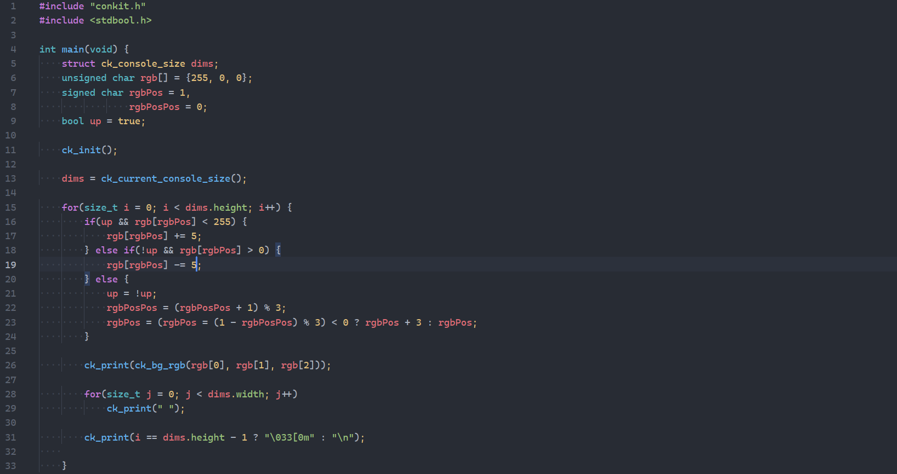
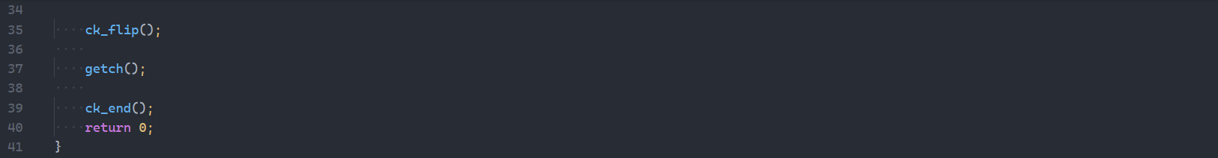

Zooming my console all the way out before running…

You might not want to do this, so just replace lines 17 and 19 with additions to a bigger factor of 255 than 5 (factors are 1, 3, 5, 15, 17, 51, 85, and 255).

You now hopefully have a basic grasp of how to use Conkit. Read through the list of definitions to discover more functionality available to you!

